Resilience Training Workshop
March 24, 2022

Outline for Workshop

Page 3: Introduction

Page 4: Module 1: Stress

Page 13: Module 2: Resilience

Page 18: Module 3: Communication

Page 24: Module 4: Personal Self-Care Plan

Page 27: Workshop Wrap Up

Introduction

This workbook is designed to accompany your Resilience Training Workshop. Specific activities were created to provide education and help you practice techniques. The material in each Module of this workbook reinforces key concepts and skills that you will learn during this workshop.

Some activities in this workshop will include group interactions and practice. Working in groups can be especially intimidating for some, but they are useful in observing one’s own behavior and receiving feedback, developing observation skills, learning to lower one’s defenses, experimenting with new behaviors, exploring social influence, discovering models, giving and receiving help, and seeing the principles of learning and behavior in action.

What information are you hoping to learn in this workshop?

Jot down any questions you have as you go through this workshop.

Module 1: Stress

Outline for Module:
- Layers of Stress
- A New Perspective on Stress and Trauma

LAYERS OF STRESS

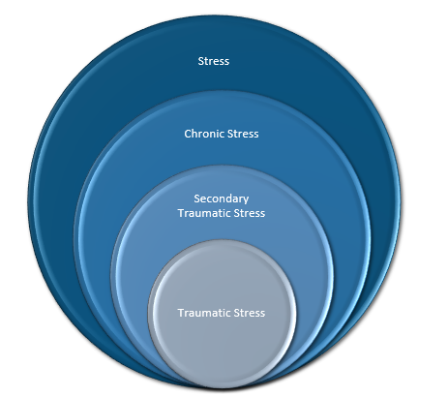
One way to view stress is by looking at different layers of stress.
- Stress: Everyone experiences stress on some level.
- Chronic Stress: A portion of the population experiences chronic stress. Often, these are individuals in high stress occupations, or with many personal demands.
- Secondary Traumatic Stress: A smaller portion of the population will experience secondary traumatic stress. This can occur in individuals working with others experiencing trauma or ongoing stress.
- Traumatic Stress: A small portion of the population may experience traumatic stress after experiencing trauma.

Stress:

Stress is defined as an interaction between environmental conditions and the person where perceived demands exceed perceived capability for managing those demands. It is the mind and body’s reaction to an unusual demand such as a threat or challenge. A stressor is any event or condition that causes a person to adapt or change. Stressors have many sources and include any situation in life requiring change or adaptation – even pleasant events like holidays or promotions. It is an individual’s interpretation of the stressor that ultimately determines the extent and demand to which stress is experienced. Whether this demand is real or imagined, outside the body or within, the body will respond in a characteristic way known as the Stress Response.

Physiological Responses to Stress

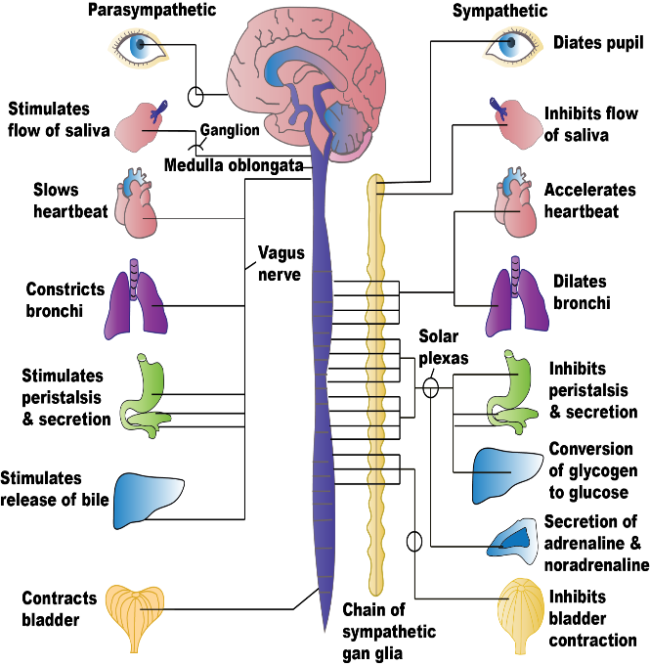
When the brain interprets something as a stressor, it sends alarm signals via nerves and hormones to prepare the body to “fight, flight, or freeze.” Consequently, senses become more alert; muscles tighten and tense for action, heart and breathing rate increase so that more blood is provided for vital organs. The cost of providing more blood for vital bodily functions is that it is diverted away from the digestive tract and skin. In addition, clotting agents enter the bloodstream in preparation for injury and stored fat and sugar supplies are released into the bloodstream as an energy supply. The normal processes of the digestive tract are shut down to save energy for emergency requirements.

In milliseconds, the brain decides what is needed for survival and focuses all its energy on these processes while pushing everything else to the side.

Normally, these responses are very adaptive and entirely appropriate in helping the body prepare for physical fight or flight activity (the sympathetic branch of our autonomic nervous system). This is because the body responds to the stressor, releases energy through confrontation, and quickly returns to normal. When the “danger” is over, the parasympathetic branch kicks into gear and tells our body to “rest and digest.”

Stress-Related Problems

Stress is not all bad. Stress can motivate and energize us to meet our goals. Our bodies were designed to use the stress response for survival: to track down prey or run from predators. However, in our modern age, while we can have a stress response to an actual acute challenge, we can also have a stress response to perceived or imagined (i.e., psychological) threats. As humans, we can stress about events or situations that have not yet happened or about something that is not even true. Unfortunately, the physiological response to these psychological threats is the same as an actual physical threat. We also turn on the stress response again and again on a frequent basis, casing wear and tear on our bodies and leading to health consequences.

Chronic Stress:

When we are exposed to chronic stressors, we can develop short-term as well as long-term health issues. Studies have shown the following:

- Loss of insulin during stress response may contribute to the onset of adult diabetes
- Stress suspends tissue repair and can cause decalcification of our bones, leading to osteoporosis
- Stress inhibits of our immune system can make us more susceptible to colds, flu, cancer, AIDS, etc.
- Stress-triggered changes to the lungs increases symptoms of asthma, bronchitis, and other respiratory conditions
- Excess epinephrine can lead to cardiovascular diseases, such as atherosclerosis, hypertension, etc.
SECONDARY TRAUMATIC STRESS
Secondary traumatic stress, also known as vicarious stress, is a result of hearing experiences of significant stress and trauma and witnessing the emotional consequence of these experiences, including pain, horror, fear, and terror. Vicarious trauma can impact sense of self and worldviews and can contribute or even lead to post-traumatic stress. In turn, helpers may experience burnout, anger, grief, or disengagement, which may negatively impact personal relations and work experiences.

Have you experienced secondary traumatic stress in your role? How have you coped with it?
There are often two possible consequences to secondary traumatic stress: compassion fatigue or burnout

Compassion Fatigue

Compassion fatigue can occur when directly working with victims of trauma and can be felt physically, emotionally, and psychologically.

As described by Charles Figley, a leading pioneer in the field of compassion fatigue:

“There is a cost to caring. Professionals who listen to clients' stories of fear, pain, and suffering may feel similar fear, pain, and suffering because they care. Sometimes we feel we are losing our sense of self to the clients we serve ... Those who have enormous capacity for feeling and expressing empathy tend to be more at risk of compassion stress."

Recognizing compassion fatigue:

As described above, compassion fatigue can have many consequences, including:

Physical: | Physical exhaustion
 | Headaches
 | Weight loss or gain
 | Difficulty sleeping
Emotional: | Having disturbing images from cases intrude into thoughts and dreams
 | Becoming emotionally detached and numb in professional and personal life
 | Withdrawing socially and becoming emotionally disconnected from others
 | Becoming pessimistic, cynical, irritable, and prone to anger
Psychological: | Perceiving the resources and support available for work as chronically outweighed by the demands
 | Having work demands regularly encroach on personal time
 | Viewing the world as inherently dangerous, and becoming increasingly vigilant about personal and family safety
 | Becoming demoralized and questioning one’s competence and effectiveness
 | Secretive self-medication/addiction (alcohol, drugs, work, sex, food, gambling, etc.)
 | Becoming less productive and effective professionally and personally
 | Distancing, numbing, detachment, cutting others off, staying busy, or avoiding listening to another’s story of traumatic experiences
 | Difficulty in maintaining professional boundaries with others, such as overextending self

Burnout

Secondary traumatic stress can also lead to burnout, though burnout can also arise from facing more daily stress than you can cope with, whether this is related to another’s experiences, work conditions, or other life events. Burnout can lead to exhaustion, cynicism, and feelings of reduced professional capacity.
Burnout is more than a bad day or a bad case.

Burnout can stem from many factors, including:
- Perfectionism
- Taking on too many responsibilities
- An inability to say “no”
- Responsibility for others’ wellbeing
- High job performance demand
- Competition
- Corporate culture

While compassion fatigue can onset quickly, burnout is a slower build over time. Warning signs of burnout include declining motivation, reduced productivity, increasing cynicism, social withdrawal, lack of attention to detail, and physical complaints such as headaches, fatigue, and body aches and pains.

Have you experienced compassion fatigue and/or burnout? What did it feel like? How did you cope?

Traumatic Stress

Some stressful events are considered traumatic in intensity. These are typically events that threaten the life, health, or safety of an individual, either directly or indirectly. Traumatic events can include natural and human-caused disasters, physical and sexual assaults, war, child abuse, and life-threatening illness. Distress and symptoms following exposure to such an extreme event may be more severe or persistent than general stress reactions.

You might experience traumatic stress in one or four ways:
- Directly experiencing an event​
- Witnessing an event in person​
- Learning an event occurred to a close family member or friend​
- Repeated exposure to aversive details of a traumatic event

Post-Traumatic Stress Disorder (PTSD) is a possible clinical diagnosis following traumatic stress. Anxiety and depression are possible as well. There are over 600,000 ways to experience PTSD and about 6.8% of the US population will be diagnosed with PTSD in their lifetime.

Symptoms of PTSD may include:

PTSD cannot be diagnosed until 30 days after a traumatic event. Additionally, symptoms may not emerge until weeks, months, or even years after the event.
PTSD is treatable through professional mental support, medication, and/or holistic approaches such as meditation. You can also buffer against possible symptoms of PTSD and traumatic stress through building strengths, coping skills, and social support.

A NEW PERSPECTIVE

Typically, we think about stress as the different types of experiences that may induce a stress-related response. From adaptive/productive stress to chronic stress and related health consequences, then moving into traumatic stress, both secondary and direct exposure. This method differentiates experiences and responses and leads to classic clinical diagnosis like PTSD and Acute Stress Disorder. Another way to look at stress and the experience of stress is on a continuum. Using a continuum helps show that everyone experiences stress reactions to come level, and diagnosable mental health conditions lie on the far end of the spectrum.

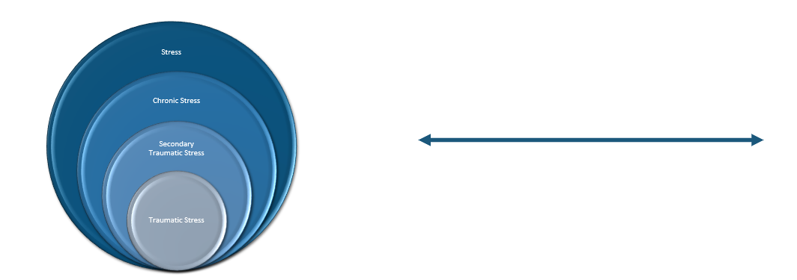
Versus

The original Stress Continuum was created by the US Marines for use in deployments and combat. The Continuum helped assess whether a Marine was “Mission Ready.”
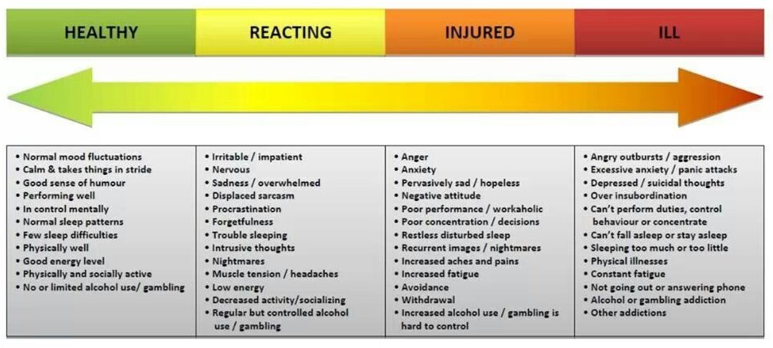

The Continuum has since been adapted to a variety of settings. Colorado Healthcare Ethics Resource (cohcwcovidsupport.org) adapted the below model from Watson et al. (2013). 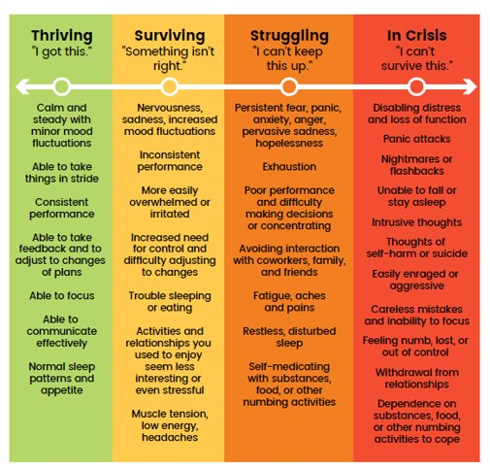
Where are you on this continuum? Where are those you are supporting?

Stress as an Injury

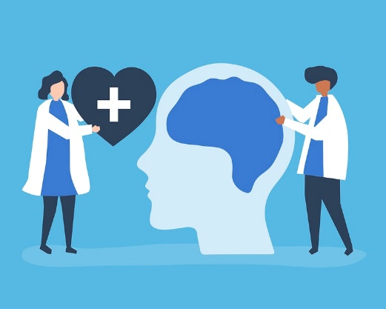
The Stress Injury Continuum views stress as an injury and uses common language of physical injuries. The brain and body are connected! What impacts the brain impacts the body and vise-versa. Therefore, cognitive and traumatic stress is still a physical injury. Just as physical injuries can range from mild to severe, stress injuries can range as well. With this model, we can view, support, and treat mental stress injuries in simialr ways we would a physical injury.

This means we can look for and assess early and late changing vital signs, support these signs and seek assistance or services when needed, and ultmately move in the other direction. A stress response is a physical injury. Using the language of physical injuries can help to reducing the stigma of discussing stress and trauma.
Imagine you are training for a marathon. You’re on a “long-run day” and on mile 10 of your goal of 12 miles that day. Suddenly you feel a pop and your knee starts to hurt. You have a few options:
1. Decide to ignore it and finish your goal of 12 miles
2. Stop to massage your knee and walk your last 2 miles
3. Decide you’re done for the day and go home

If you decided a keep running, one of two things may happen. 1 – The pain goes away and you’re able to continue training. Or, 2 – The pain continues. If the pain continues, you might try to ice and elevate it and treat it on your own, or you may choose to go check in with a doctor or physical therapist.

We have the same options when we experience a stress injury. If we recognize early signs (for example: nightmares, hypervigilance, anxiety, depression, etc.), we can choose to ignore it or use coping skills. We may then choose to see a professional for assistance if we are no longer able to cope on our own.

Notes/Take-aways on Module 1: Stress

Module 2: Resilience

Outline for Module:
- Resilience
- Self-Efficacy
- Self-Care
- Using the Stress Injury Continuum

RESILIENCE

Resilience is a bit of a buzzword these days! Due to the prolonged stress brought on by the COVID-19 pandemic, many are looking at how to instill and foster resilience in themselves and others.
Resilience means the ability to “bounce back.” It does not mean that an individual is never stressed, or that stress or trauma does not affect him or her. Rather, it is the ability to quickly return to a “pre-trauma” or “pre-stress” state. The more this rebound occurs, the more resilient the individual becomes to future hardships.
The experience of adversity alone does not create resilience; it is the experience of successful coping that is important. Resilience is based on effective utilization of resources, flexible coping, active management of personal distress, and ability to seek opportunities to help others.

Resilient People:
- Are effective at identifying what they can control and developing strategies to recognize and acknowledge success as they cope
- Thrive on turning stressors into challenges, rather than viewing difficulties as threats
- Have confidence in their abilities to manage what’s coming at them
- Are good at self-care and work to take care of their emotional and physical health
- Persevere when they hit roadblocks and, when they do fail, they turn that into a learning opportunity in order to succeed again
- Help other people to cope, believing in the concept that collectively we will succeed, alone we will not

What does resilience look like to you?

SELF-EFFICACY

Self-efficacy centers around an individual’s belief in their ability to handle the stress and threats that the stress is causing. Self-efficacy also plays a large role in developing resilience. A strong sense of coping self-efficacy provides a person with a sense of control over the situation. We build self-efficacy through:

Effectively handling difficult challenges (i.e., mastery)
Seeing others, like a friend or family member, effectively handling stressors
Receiving support from a friend or loved one who encourages “you can do this!”
Effectively managing one’s physical or emotional distress

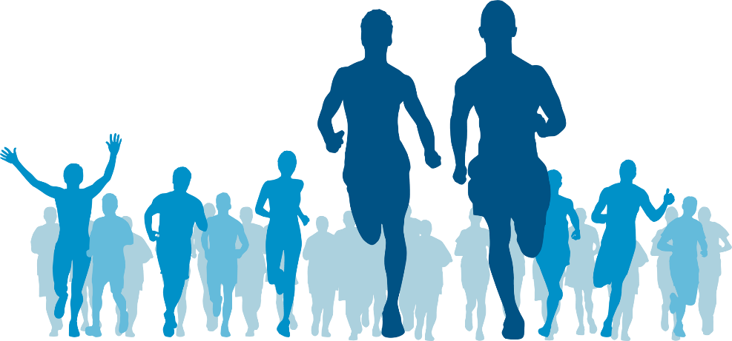
Think about marathon runners. Marathoners did not put on their
shoes the first day of training and run 26.2 miles! They started with
what they could accomplish that day. Maybe it was three miles, maybe one, or maybe it was a walk around the block. Then when the three miles/one mile/walk felt achievable, the distance was increased, bit by bit, until the runner could run 26.2 miles (mastery experience)!

In learning how to run a marathon, the runner also learned how to breathe effectively and regulate emotions. Then, when they run the race, they run with others who are also demonstrating the ability to run a marathon (vicarious experience) and there are people on the sidelines cheering them on (social persuasion). Finally, the runner considers their own physical and emotional state: do they have achy knees, pre-run jitters?

Taking all of this is account, the runner runs a marathon!

What is a challenge you have overcome in your past, or a goal you accomplished? How did you build the ability to overcome this challenge or goal?
How can others use self-efficacy for their own challenges? How could you support this process?

SELF-CARE

Another recent buzzword is self-care. Self-care is a preventative measure against burnout, compassion fatigue, and stress. It is also multifaceted, meaning we can engage in self-care in a variety of ways, such as spending time alone to “refuel,” saying no to new projects or responsibilities, setting boundaries, or engaging in relaxing or soothing activities.

Self-care can also at times feel stressful, especially when you work in a demanding field. It’s easy to say we “should” time off work for self-care, check into a spa, go on vacation, etc. These “should” sound enticing and for many, may not seem possible. In fact, the weight how you “should” self-care can cause stress itself! (The brain is a tricky beast). In reality, self-care is simply choosing your own personal needs in times of stress. Coping is simply an activity that distracts or soothes in the moment. We can choose realistic ways to do both while still managing the demands of our jobs and lives.

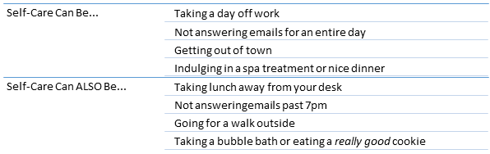
Think about your day and areas of your day or job that create stress. What ways can you realistically cope with those areas?

- If emails bog you down and inhibit you from being able to enjoy your time at home, can you set some new boundaries around not checking your email after 6:00 pm?

- If you feel like you go the whole day without stopping, can you find a way to take a 30-minute lunch break away from your desk?

- If you feel like you are always giving yourself to someone else’s needs, what are some small ways you can meet your needs first or next?

The take-away is make your boundaries and self-care fit your needs and allow yourself to be flexible in doing so.

Facets of Wellness

Wellness is more than emotional and physical fitness. You can discuss wellness without ever discussing feelings.

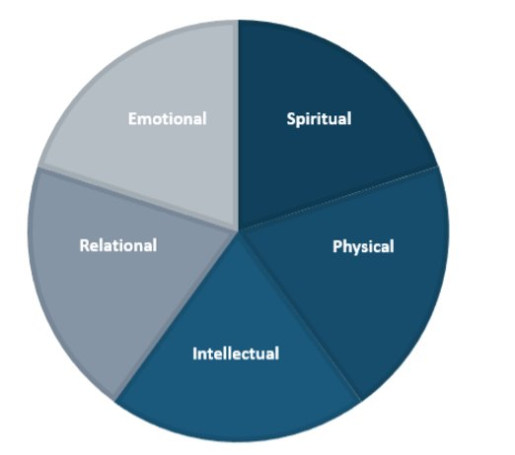
- Spiritual wellness is how we connect with the “unknown” or something “bigger” than ourselves. It may be religion, meditation, or connecting to the outdoors.
- Phsycial wellness is moving our bodies and may include an exercise goal or may simply be reminders to move each day.
- Intellectual wellness refers to the ability to engage the mind or be creative.
- Relational wellness includes how social we are choosing to be and the quality of our relationships
- Emotional wellness is the ability to express and support a vaierty of emotions

How can you use the above pie chart to discuss overall wellness in your role?

Using the Stress Injury Continuum

As discussed in Module 1, the stress injury continuum is a way to look at stress reactions on a spectrum. It can also be used to assess how to move towards Green, or “Thriving.” If you or someone you are supporting is finding themselves in the Yellow, Orange, or Red categories, several coping strategies or support can help. Green is a goal, not a destination. This means we will inherently fluctuate on this continuum based on the ongoing events in our lives. We can always work on returning to or staying in “Green.”
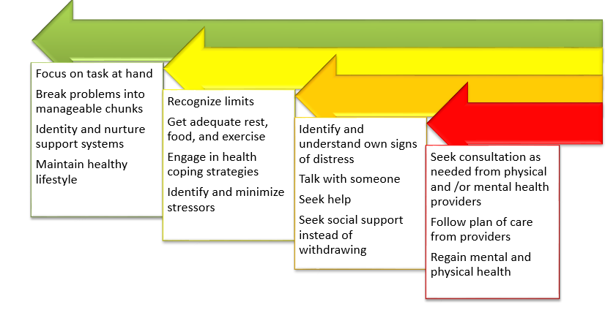

Notes/Take-aways on Module 2: Resilience

Module 3: Communication

Outline for Module:
- Active Listening Skills
- Empathy
- Validation
- The Wall

ACTIVE LISTENING SKILLS

Active (reflective) listening skills can assist in your communication with others, especially those experiencing stress or crises. These relatively simple skills show you are listening, engaged in the conversation, and willing to hear more and help. These skills are best described, and practiced, in the following communication pyramid:

Starting at the bottom and working your way up, you can practice these techniques one step at a time. It is also important to remember that effective communication involves 80% listening and 20% talking.

Silence | Sometimes the most useful thing to do is support silently. Sitting silently while a someone is trying to find the right words to say, or sobbing may be difficult when you may want to provide support through words.
Feedback/Minimal Encouragers | Minimal encouragers demonstrate that the listener is tracking what the speaker is saying and is encouraging the speaker to continue.
Parroting | As the term suggests, this skill requires repeating key words the speaker has said. When using this skill, repeat only one or two words rather than entire sentences.
Paraphrasing | This feedback skill requires the ability to repeat what you heard in your own words. It communicates the essence of what the speaker said to clarify your understanding and demonstrate a stronger sense of interest.

Questioning | The questioning process can be broken into two categories, open and closed questions.
 | - Closed questions elicit only a yes or no response. They may also be questions that elicit a short response with no opportunity to elaborate. They are helpful in obtaining specific information.
 | - Open questions using phrases such as “Can you tell me more?,” “How does it make you feel?” “Help me understand....” are useful in getting someone to open up.
 | - Asking “Why” questions can often get the typical response of “I don’t know” or “Because.” The use of why questions can connote an interrogation or judgmental style of questioning. Use why questions carefully.
Empathy | The ability to place oneself in another’s situation is the epitome of empathy. Pay particular attention to the message both psychologically and physically. Move gradually through the exploration of sensitive topics and feelings. After responding, pay attention to body language, voice, and word cues that either confirm or deny the accuracy of your response.
Reflective/Active Listening | This skill involves combining all steps of the pyramid into a comprehensive system of effective communication. Reflective listeners listen for the underlying feels, the feelings that may not be said allowed but are implied by the speaker. As a mirror reflects an image, reflection of feelings reflects the feelings the speaker is conveying. Because most of us talk around feelings but never bother to identify the feelings the real issues are never discussed.

EMPATHY

What do you believe is the difference between empathy and sympathy? Do you think it is good or bad to have empathy in this field? How might empathy help or hinder your job?
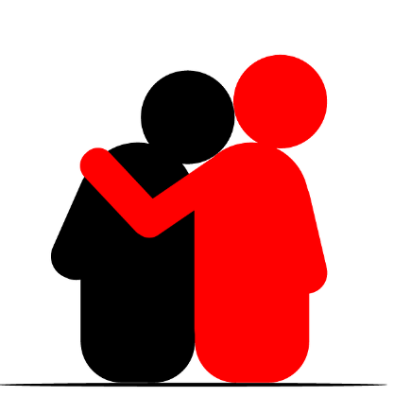
Empathy is the skill of understanding another person’s feelings or point of view and the ability to communicate that understanding. Empathy involves putting yourself in the other person's shoes and understanding why they may have these particular feelings. Empathy helps a person to feel heard, understood and validated.
Sympathy, on other hand, is understanding another person’s experience from your point of view. Sympathy also inherently involves a level of judgement, whether intentional or not.
For example, if someone recently lost a loved one, a sympathetic response may sound like, “I’m sorry for your loss.” An empathetic response may sound like, “I imagine you’re in a lot of pain right now, this must be really hard.”
You may feel empathy for someone because you’ve been in a similar situation. You can also feel and express empathy for someone even if you have not experienced the same type of event by imagining what that person may be feeling. You can always use a “check-out” phrase if you are unsure of the right feeling: “It seems like you might be frustrated right now, is that right?”
Expressing and receiving empathy can be very powerful! It communicates a shared understanding without having to use a lot of words. It can also move the conversation towards help or support, such as, “It sounds like your workload feels very stressful right now. I imagine you’re feeling a little burnt out. What are you doing to take care of yourself?” or even simply, ”I understand how you’re feeling. I want you to know I’m here to listen and help if I can.”
Empathy can deepen relationships and promote helping behaviors. It can also instill compassion and understanding in times of stress. It can also improve professional interactions with others.
Too much empathy, however, can cause strain on the individual expressing it. Because empathy instills a shared experience, constant empathy for others can make us feel drained , exhausted, and even stressed. Ultimately, constant empathy can lead to burnout and can reverse our ability to feel empathetic towards others.

VALIDATION

Validation often goes hand-in-hand with empathy and in fact goes a step beyond empathy. Validation involves acknowledging the experience without judgement. When you validate someone, you are verbally communicating your understanding of their unique experience and accepting their point of view. You can validate and accept a situation without approving of the situation. For example, if someone you are working with chooses to use substances as a coping mechanism, a validating statement might sound like, ”It sounds like drinking is allowing you to escape this situation, I can understand why that might feel better than facing the reality of what’s happening.” Many people go their entire lives without being validated for their feelings and experiences. For this reason, validation can be incredibly powerful. Listening without judgement provides a safe space for someone to express their emotions and can lead to a better discussion of support and change, versus forcing the issue without validating the experience.
“Drinking is going to make your situation worse. You cannot provide for your children while you’re intoxicated, and the judge is going to see this.” This statement may be entirely true! And may also prompt a defensive or defeated position.
”It sounds like drinking is allowing you to escape this situation, I can understand why that might feel better than facing the reality of what’s happening. I’m also concerned it may worsen your position in court. What can you do to give yourself that feeling of escape in a more positive way?” Here you are still expressing your concern for the behavior, but you’re coming from a place of support and looking for a better solution.

It’s Not About the Nail
As helpers, we often want to “fix” the problem. And we might see many ways to “fix”the problem! Sometimes, however, the more powerful thing to do in that moment is simply to listen.
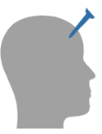
If someone has a metaphroical “nail” in their head, they likely know the nail is there. They know it’s causing them pain and they know if they could remove the nail they would feel a lot better. But removing the nail isn’t always that easy and when we focus solely on removing the nail, we invalidate the pain it is causing.
Empathize and validate first, offer or brainstorm solutions second.

THE WALL

Sometimes helpful conversations are instead met with a wall of confrontation, denial, or resistance. Helpers are there to provide support and resources, but this can prove difficult when someone is resistant to help. It’s important to remember we cannot force help on someone. There are some skills, however, that can be helpful in breaking down this wall.

Validation
As mentioned above, validation can be a very useful skill in showing someone you acknowledge and empathize with their experiences. At times, simply validating someone can start to break down their walls and instill trust. You can continue to build the relationship until the other person feels more comfortable sharing deeper experiences.

Stages of Change
When someone is making major life decisions, or even choosing to trust another to share their experiences with, they may go through stages of change. An individual will move through these stages, or go back and forth several times, on their own. You cannot force change or force a shift in the stages. You can, however, help someone recognize what stage of change they may be in.
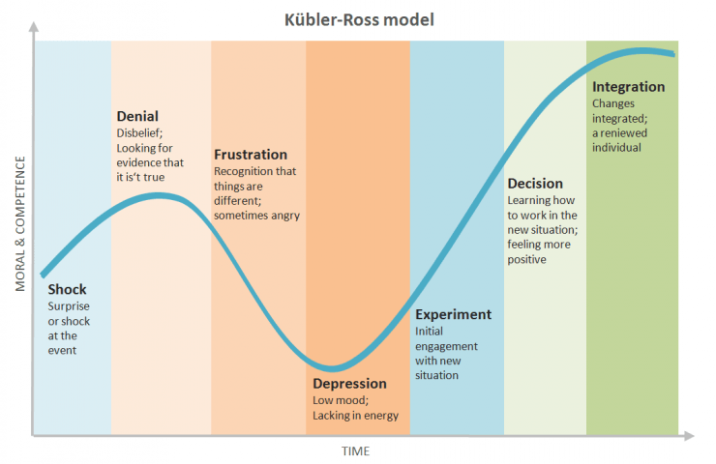

Reflection and Mirroring

Mirroring is a non-verbal skill that may be used to help an individual understand his or her own experiences. It can also be used to help another person open up and/or relax. The mirroring action allows an individual to align themselves with whom they are speaking. For example: choosing to sit face to face the other person instead of assuming a higher position (i.e., standing or sitting on a desk) communicates an interest on the same level. This body language conveys a message of interest and willingness to help. Nonverbal behavior can confirm, deny, strengthen, or control what is being said. Additionally, the more “open” your body language is, the more likely the person opposite of you will start to open as well. The same is true if you are tense.

Modeling

We can also model helpful and healthy behavior for others! By modeling communication and coping skills we can help demonstrate effective skills and allow others to vicariously learn through us.
Notes/Take-aways on Module 3: Communication

Module 4: Personal Self-Care Plan

Personal Stress Style (Created by Daniel Goleman, PhD)

Imagine yourself in a stressful situation. When you are feeling anxious, what do you typically experience? Check all the numbers that apply.
My heart beats faster
- I find it difficult to concentrate because of distracting thoughts
- I worry too much about things that don’t really matter
- I feel jittery
- I get diarrhea
- I imagine terrifying scenes
- I can’t keep anxious-provoking pictures and images out of my mind
- My stomach gets tense
- I pace up and down nervously
- I am bothered by unimportant thoughts running through my mind
- I become immobilized
- I feel I am losing out on things because I can’t make decisions fast enough
- I perspire
- I can’t stop thinking worrisome thoughts
Give yourself a “Mind” point if you checked any of the following: 2, 3, 6, 7, 10, 12, and 14.
Mind Total: _______________
Give yourself a “Body” point if you checked any of the following: 1, 4, 5, 8, 9, 11, and 13.
Body Total: _______________
If stress registers mainly in your body, you will need a remedy that will break up the physical tension pattern. This may be a vigorous body workout, or a slow-paced (even lazy) muscle relaxer. Examples: Aerobics, Progressive relaxation, Swimming, Biking, Rowing, Running, Walking, Yoga, Massage, Soaking in a hot tub, Deep breathing.
If you experience stress as an invasion of worrisome thoughts, the most direct intervention is anything that will engage your mind completely and redirect it. Examples: Meditation, Exercise, Reading, Crosswords, Puzzles, TV, Movies, Games (chess, cards), Knitting, Sewing, Carpentry, Handcrafts, Creative imagery.
If you experience a mixed type, you may try a physical activity that also demands mental rigor. Examples: Competitive sports, Tai Chi, Tae Kwan Do, Any combination of mind and body activity

Making Green Choices

Making Green Choices means choosing activities that may move you down the continuum bit by bit.
Prioritize self-care, both within and outside of work
Focus on what you can control, try to let go of what you cannot control
Seek social support and connections within and outside of work
Create realistic goals for yourself
Find a passion project/hobby not related to work
Find your joy each day
Focus on different areas of coping each day

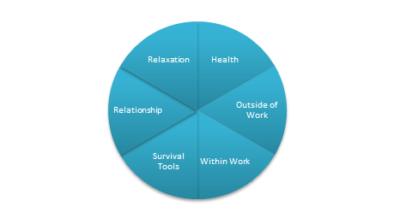

Using the pie above, what are Green Choices you could make in each area?

Self-Care Worksheet

Take a few minutes to examine your current self-care. What do you do now to engage in wellness in each of these six areas? What would you like to add? Remember, even small actions can make big differences

Healthy eating and drinking | Now: | New:
Exercise | Now: | New:
Social Support | Now: | New:
Mood boosting activities | Now: | New:
Relaxation and calming | Now: | New:
Sleep | Now: | New:

Workshop Wrap-Up

Consider your questions on page 3. Were they answered? Do you have any remaining questions?
What was the most helpful part if this workshop?
What skills do you want to practice more? Who can you practice with?

